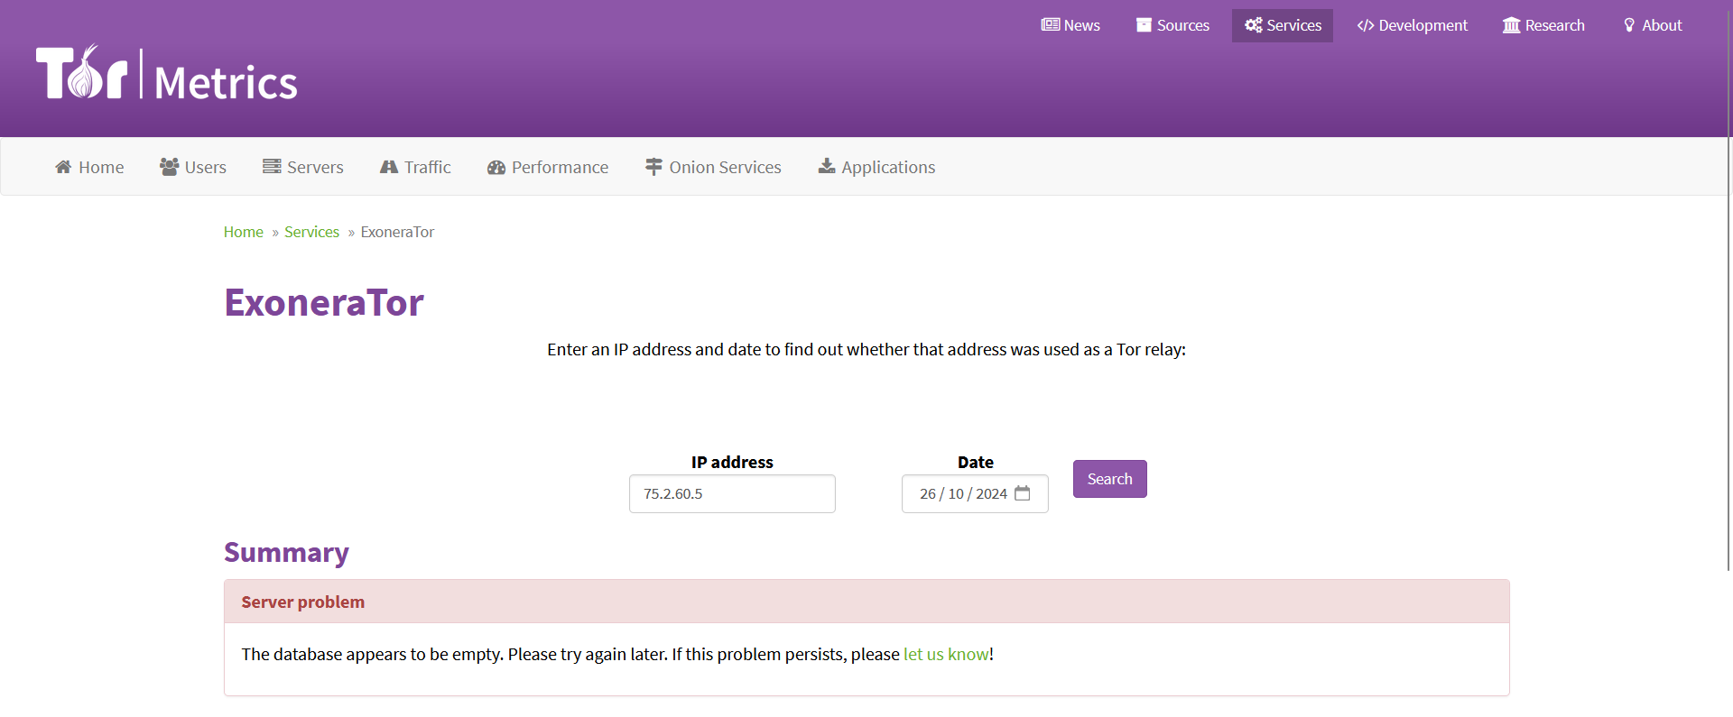

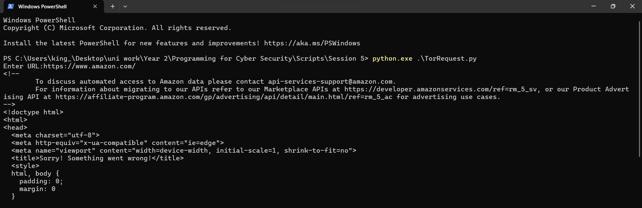

Unable to install 4 and 5